

BTS West Cust Code BioSolar Group / CytoCulture
1711 Orbit Way -- Bldg 2 Attention Of Randall von Wedel, Ph.D. RvWedel@gmail.com
Minden, NV 89423 Company CytoCulture International, Inc.
TEL: 775-783-4660 End User City of San Francisco
FAX: 775-783-4651
Taken 1/30/2008 Received 1/31/2008 Unit ID 08-12 Rail Car Prox77244
Tested 1/31/2008 Reported 1/31/2008 Test Pkg FTG+TAN+KFW+FPCC
Fuel Type Biodiesel Fuel

Biodiesel Quality Status Report for B100: Rail Car Prox77244 sampled on 01/30/2008

Unit ID 08-12 Batch Number 7055
Date Sampled 1/30/2008 Sample Number 3332
Test Name Test Method Limit Result Status
Free Glycerin (mass %) ASTM D 6584 MAX 0.020 0.000 PASS
Monoglycerides (mass %) ASTM D 6584 N/A 0.000 N/A
Diglycerides (mass %) ASTM D 6584 N/A 0.019 N/A
Triglycerides (mass %) ASTM D 6584 N/A 0.000 N/A
Total Glycerin (mass %) ASTM D 6584 MAX 0.240 0.019 PASS
Flash Point, Closed Cup (°C) ASTM D 93 MIN 130 184 PASS
KF Water (ppm) ASTM D 6304 N/A 725 N/A
TAN (mg KOH/g) ASTM D 664 MAX 0.50 0.13 PASS

B100 fuel (top/middle/bottom) vs. corresponding pHLip Test Result (B100 Reference on right) at 10 min.
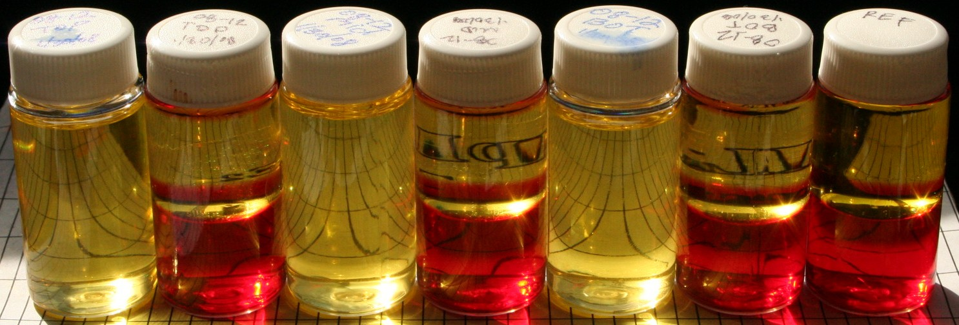

Rail Car Prox 77244 B100 sampled on January 30, 2008 and corresponding pHLip Test Results on the same day for Top, Middle and Bottom of the rail car. pHLip Test results indicate excellent quality biodiesel with no color change or turbidity in the red indicator solution, clear and bright B100 fuel layer and a perfect mirror finish in all 3 test vials. There is no evidence of any contaminants as corroborated by the laboratory analytical data for the composite sample (25% top:50% middle:25% bottom). The composite sample passed all 4 of the selected tests for ASTM D-6751. The total free & bound glycerin level was very low at only 0.019% (monoglycerides were below detection). KF moisture was 3x higher than normal suggesting the biodiesel may have been exposed to rain/weather in transit or upon arrival in CA. However, the low acid number (TAN = 0.13) indicates the fuel had not oxidized appreciably. The moisture in the fuel should not present a problem for high turn-over fueling applications but it is worth discussing with supplier & distributor. Conclusion: Excellent, clean biodiesel although somewhat moist.

